First Aid - Emergency Action Plan – TRFC – 2026
Away teams are responsible for making their own arrangements for first aid. The club has provided the following details for your information.
Club Location : Truro Rugby Football Club, St Clements Hill, Truro, TR1 1NY
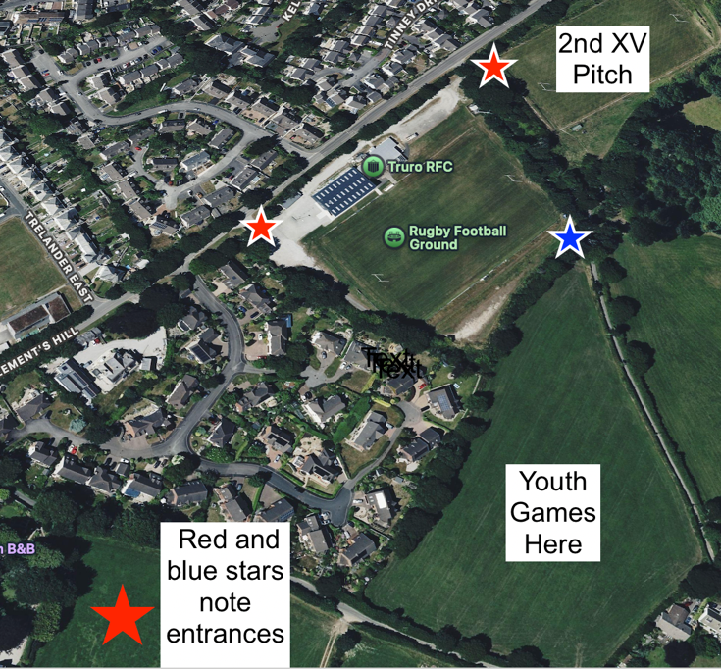
First Aider Via BAR STAFF Club Contact Number 01872 274750
First Aid Equipment – Main bar and all TRFC age groups
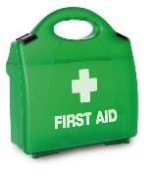
First Aid Room - TREATMENT ROOM in new changing room area
First Aid Kit - CHANGING ROOM CORRIDOR & BAR Stretchers/Collars/Splints – Behind bar
Defibrillator
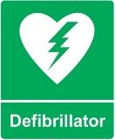
Defibrillator - WALL OUTSIDE FRONT DOOR
Nearest A&E Hospital
Royal Cornwall Hospital, Treliske, Truro, TR1 3LJ
Telephone: - 01872 250000 Journey Time @ 15 minutes
Please ensure ambulance route accessible to pitches at all times

